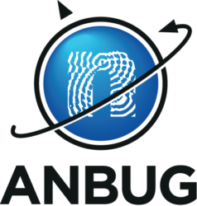
ANBUG Awards 2022 Nomination Form

Nominee’s details
Title & Name
Affiliation
Nominated by
Nominated for ☐ Career Award ☐ Neutron Award (>10 years post PhD)
(tick one only) ☐ Young Scientist Award (<10 years post PhD) ☐ Technical Award
☐ Outstanding PhD Award
Brief description of reason for nomination (around 200 words)
Up to ten significant publications using neutron methods
Any other information that may be relevant to the nomination

Forward nomination to the ANBUG Secretary (secretary@anbug.net) by September 30th, 2022

